**STEVEN R. ENCARNACION**

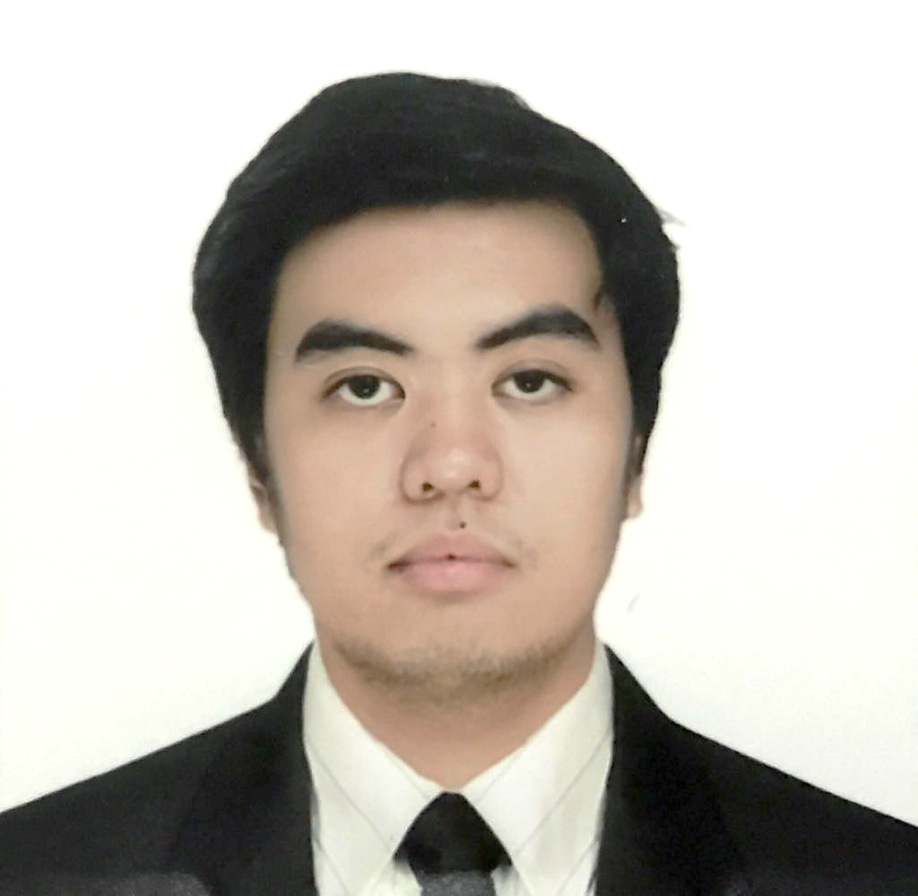

Skype ID: steven_enc

+639456217853

steven.enc@gmail.com

**OBJECTIVE** To acquire a position in a reputable organization where I can maximize my skills and proficiency and to provide a positive contribution for the society.

**EDUCATION**

2011-2017 DE LA SALLE UNIVERSITY-MANILA

Bachelor of Science Degree in Mechanical Engineering with Concentration in Mechatronics Engineering, June, 2017. OWWA-EDSP Scholar. Dean’s List: 2nd Term, AY 2011-12; 3rd Term, AY 2011-12.

2007-2011 DON BOSCO TECHNICAL INSTITUTE-MAKATI

Academic Diploma, March 2011. Technical Diploma in Computer Technology, March 2011. Awardee: Loyalty, 2011.

**SEMINARS ATTENDED**

July 2012 ENGINEERING DESIGN SUMMER PROGRAM 2012

Faculty of Engineering, National University of Singapore.

**WORK EXPERIENCE**

July 2018 to Present PROJECT SPECIALIST,

ALPINE OPUS TECHNOLOGIES CORPORATION

June to Dec 2017 RESEARCH AND DEVELOPMENT SPECIALIST,

POWERTECH ASIA PACIFIC

Feb to May 2017 INTERN, POWERTECH ASIA PACIFIC

**CO-CURRICULAR ACTIVITIES**

2016-2017 ADVOCACY COMMITTEE, CENTER FOR SOCIAL CONCERN AND ACTION – LASALLIAN OUTREACH AND VOLUNTEER EFFORT

Ideates and deliberates plans for member advocacy statement of social issues and immersion with destitute communities.

**STEVEN R. ENCARNACION**

page 2

2015-2016 PRESIDENT, AMERICAN SOCIETY OF MECHANICAL ENGINEERS

Accomplished projects such as Automotive Maintenance Scholarship and Taft Girls U-Night, where female K-12 students are introduced to STEM subjects through seminars and competitions.

2014-2016 PHOTO STAFFER, MALATE LITERARY FOLIO

Attended fine art workshops selectively funded by the organization such as Fotosemana 2015 Manila Master Class by Spanish artist Nicolás Combarro.

2014-2015 ASSISTANT VICE PRESIDENT FOR MULTIMEDIA, MECHANICAL ENGINEERING SOCIETY

Managed the production of event posters and documentation of organizational events.

2014-2015 KASAPI NG RETRATO, ANG PAHAYAGANG PLARIDEL

Documented and published national and campus issues in University publication. Awarded: Retrato ng Buwan, July and August 2014.

2014-2015 VICE PRESIDENT OF INTERNALS, AMERICAN SOCIETY OF MECHANICAL ENGINEERS

Administered the internal processes and archives significant documents of the organization.

2013-2014 VICE GOVERNOR OF SOCIO-CIVIC, MECHANICAL ENGINEERING SOCIETY

Conducted projects promoting social awareness and organizational immersion with nearby communities.

2013-2014 FUND COUNCIL, AMERICAN SOCIETY OF MECHANICAL ENGINEERS

Assisted in fund raising activities and financial upkeep of the organization.

2012-2013 INFORMATION EXECUTIVE, ENGINEERING COLLEGE GOVERNMENT

Supervised dissemination of announcements and organizational events.

2011-2013 FINANCE OFFICER, MECHANICAL ENGINEERING SOCIETY

Aided documentation and upkeep of organizational funds.

2011-2012 ADVOCACY COMMITTEE, BATCH GOVERNMENT

Headed activities concerning advocacy regarding social issues.

**PERSONAL BACKGROUND**

Born on June 14, 1994 in Makati, Philippines. Fluent in English and Filipino. Knowledgeable in Microsoft, Adobe, SolidWorks, and AutoCAD programs. Well-organized, resourceful, and does quality work completely on time.